**University of California, Riverside**

**EE/ME144, EE283A**

**Foundations of Robotics**

**Fall 2022**

**Lab 1 Report**

**10/07, 2022**

| **Name** | **SID** | **Section** | **Group Number** |
| --- | --- | --- | --- |
| **Tianzi Luo** | **862251424** | **021** | **XX** |

# 1. Problem Statement

**Lab 0: Preparation**

1. Download and install VMware. (VMware Workstation Player)
2. Download Ubuntu 16.04 and create a new VM in VMware.
3. Start installing ROS following the ROS [installation tutorial](http://wiki.ros.org/melodic/Installation/Ubuntu).

**Lab 1: Run in Gazebo**

1. open a new terminal, and create a new ROS workspace.
2. Set up Turtlebot in Gazebo

- upgrade existing packages

- install some dependencies

1. Launch Gazebo simulator and spawn a new robot
2. Set up robot arm in Gazebo

-download the ROS packages for the robot arm

-install the dependencies

1. Play with robot arm

# 2. Design Idea

Before working with robots, we need first to get the development environment ready. Installing a virtual machine with a Linux system, and then getting the ROS.

Lunch two basic robots, Turtlebot and a robot arm. Play with them.

Be familiar with Gazebo and RViz.

Try to do everything in the terminal with commands.

Some basic commands:

**ls:** lists all the files in the subdirectories.

**cd:** goes to another directory.

**roscd:**  It allows you to cd directly to a package, stack, or common location by name.

**echo:** display line of text/strings passed as an argument.

# 3. Results

Steps and results.

**Step1: Get a virtual machine, install Linux, and install ROS.**

Have the ROS workspace and the ROS package ready.

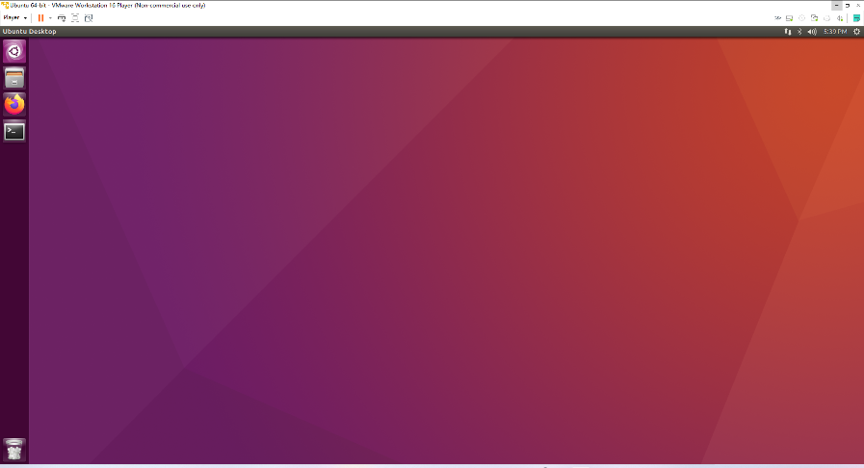

**Step2: Spawn the robot in Gazebo**

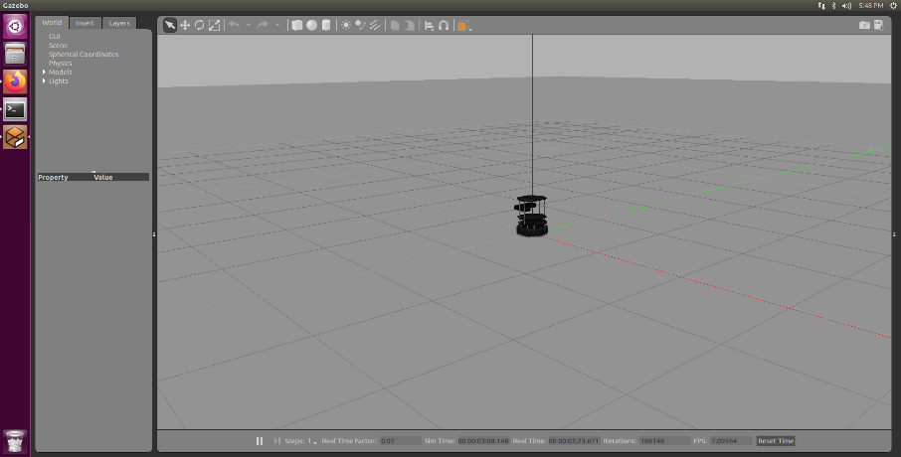

**Step3: Move the robot**

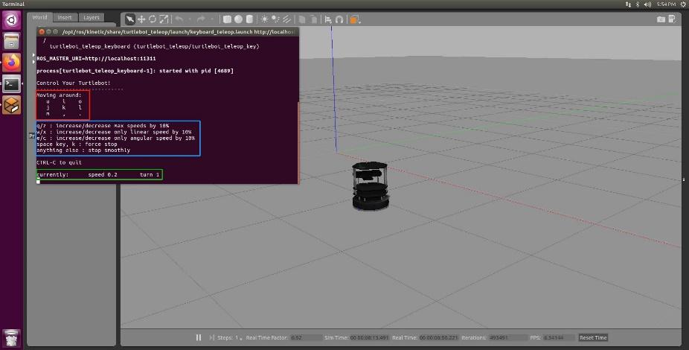

Control the robot:

*Crtl+t: back to the origin

*Moving around:

U I O

J K L

M , .

*Force stop: space & k

**Step4: Launch a ReactorX 150 robot arm in Gazebo**

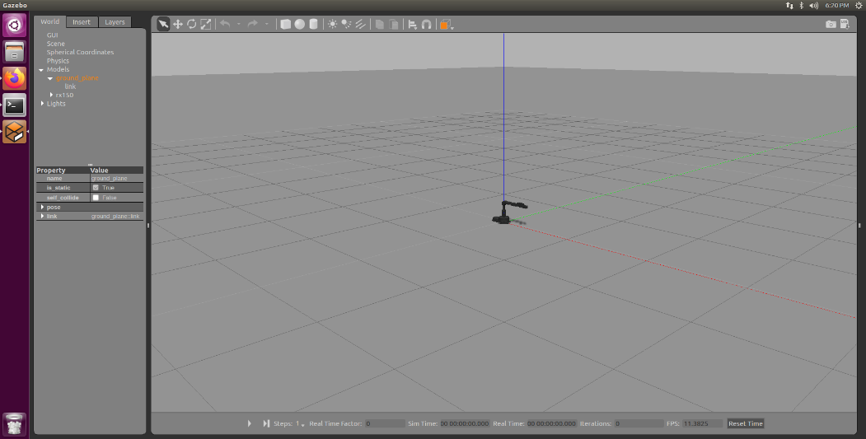

Click the play button.

**Step5: Using Gazebo and RViz to play with the robot arm together.**

RViz provides a tool for better interaction, but only Gazebo shows the real physical status.

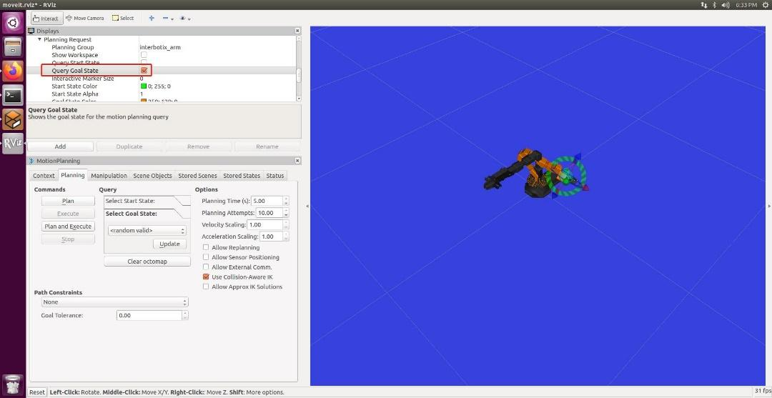

On RViz:

1. “MotionPlanning” -> “Planning Request” -> “Query Goal State” and check this box. Drag the “ball” on the tip of the robot arm.
2. “Planning” tab and try buttons “Plan”, “Execute”, or “Plan and Execute”. See robot arms in two software play simultaneously.

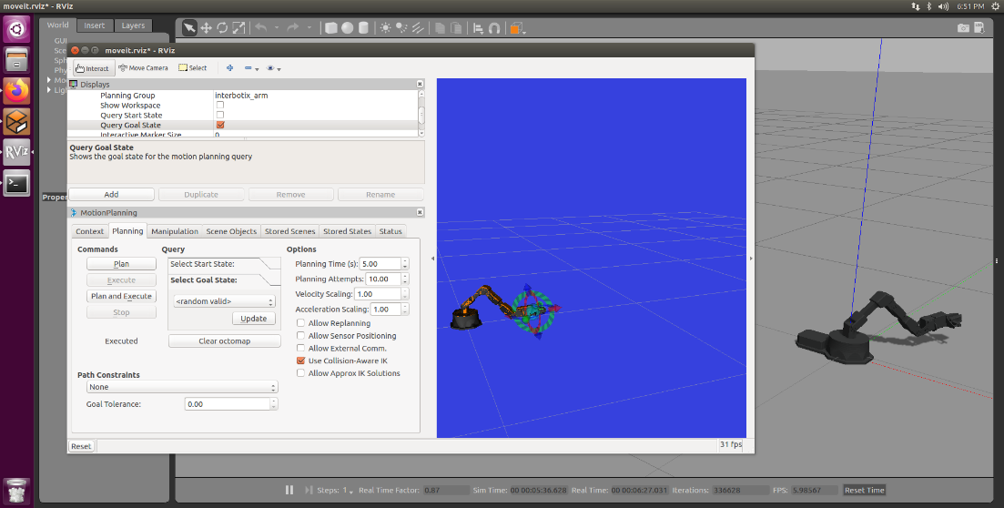

# 4. Appendix (optional)

## 1) How to run the code

Follow the instructions and run the commands in terminals.

## 2) References

Lab instruction: <https://ucr-ee144.readthedocs.io/en/latest/lab1.html>

[VMware Workstation Player](https://www.vmware.com/products/workstation-player/workstation-player-evaluation.html): <https://www.vmware.com/content/vmware/vmware-published-sites/us/products/workstation-player/workstation-player-evaluation.html.html>

Ubuntu 16.04: <http://releases.ubuntu.com/16.04/>

Linux command: <https://ubuntu.com/tutorials/command-line-for-beginners#8-hidden-files>

## 3) Scripts

## Same with the instructions.

## 